Creating a log file
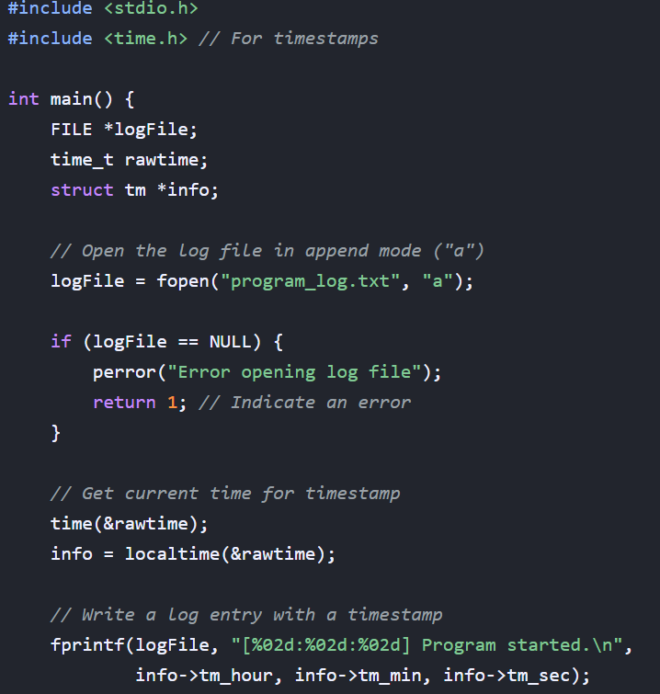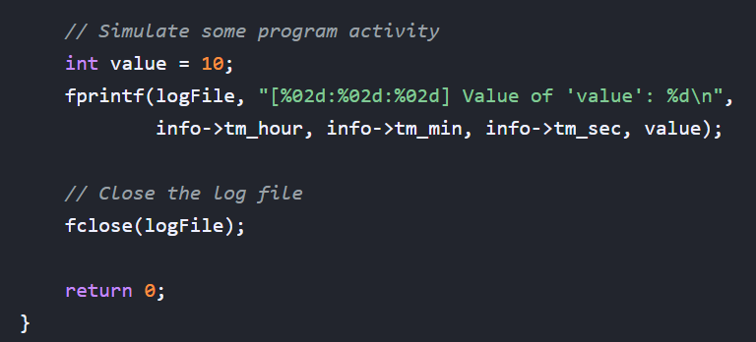

Purpose of Text Log Files in C:
- Debugging and Error Tracking:
Logs can capture error messages, variable values at specific points, and function call sequences, aiding in identifying and fixing bugs.
- Monitoring Program Behavior:
They can record timestamps and details of critical operations, allowing for performance analysis and understanding how the program is functioning.
- Auditing and Security:
Logs can track user actions, system changes, or security-related events for auditing purposes or to investigate potential security incidents.
- Information and Reporting:
They can provide a historical record of program activity, useful for generating reports or understanding past events.
How to Create and Write to Text Log Files in C:
C utilizes standard file I/O functions to interact with text log files. The general process involves:
- Opening the File:
Using fopen() to open a file in a specific mode (e.g., "w" for write, "a" for append).
- Writing Data:
Using functions like fprintf() to write formatted text (including variables, strings, etc.) to the opened file stream.
- Closing the File:
Using fclose() to close the file, ensuring all data is written and resources are released.

Table Structure using for loop
